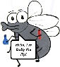

Lyng Primary School Knowledge Organiser

Topic: | Science  Electricity and circuits | Year 4 | Autumn 2


/
Notable scientists
Benjamin Franklin
(discovered that lightening is electrical. Most credit for discovering electricity is given to him)
Thomas Edison
(invented the first electric lightbulb.)

What should I already know?
- Children have not been introduced to Electricity yet within Science.
- Electricity is a form of energy that can be carried by wires and is used for heating and lighting, and to provide power for devices.
- Sources of light and sound may need electricity to work.
- That some devices within their homes and schools will use electricity.
- That a switch turns electric on and off (such as a light or mains plug)
- That some torches or toys may use batteries.
What Step On and Goldilocks words will I use?
Spelling | Definition
Appliances | a device or machine in your home that you use to do a job such as cleaning or cooking. Appliances are often electrical.
Battery/ Cell | small devices that provide the power for electrical items such as torches
Bulb | the glass part of an electric lamp, which gives out light when electricity passes through it
Circuit | a complete route which an electric current can flow around
Conductor | a substance that heat or electricity can pass through or along
Current | a flow of electricity through a wire or circuit
Electricity | a form of energy that can be carried by wires and in used for heating and lighting, and to provide power for devices
Energy | the power from sources such as electricity that makes machines work or provides heat
Fuel | a substance such as coal, oil, or petrol that is burned to provide heat or power
Insulator | a non-conductor of electricity or heat
Mains | where the supply of water, electricity, or gas enters a building
Motor | a device that uses electricity or fuel to produce movement
Power | Power is energy, especially electricity, that is obtained in large quantities from a fuel source and used to operate lights, heating, and machinery
Switch | a small control for an electrical device which you use to turn the device on or of
Wires | a long thin piece of metal that is used to fasten things or to carry electric current

Investigate!
- Explore different electrical appliances and decide whether they are mains or battery operated.
- Investigate the electrical current in a circuit
- Construct a simple electrical circuit with a switch
- Investigate how to make a complete and incomplete circuit
- Investigate to find out which materials are either electrical conductors or insulators
- Build a switch that works effectively in an electrical circuit

Enquiry Questions
- How are electrical appliances powered?
- How do I construct an electric circuit?
- How do switches in a circuit work?
- How do materials act as conductors or insulators?
- What affects bulb brightness?
- How can we be safe around electricity?
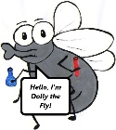
What will I know by the end of the unit?
Where does electricity come from? | 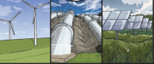  - Electricity is generated using energy from natural sources such as the Sun, oil, water and wind  - These can also be called fuel sources
Which appliances run on electricity? | 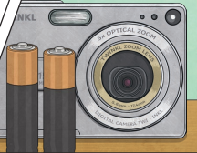  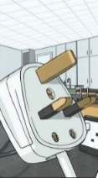  - Some appliances use batteries and some use mains electricity.  - Batteries come in different sizes depending on how much and for how long the appliance is used.  - Common appliances that use electricity.
How does a circuit work? | - A complete circuit is a loop that allows electrical current to flow through wires.  - A circuit contains a battery (cell), wires and an appliance that requires electricity to work (such as a bulb or motor).  - The electrical current flows through the wires from the battery (cell) to the bulb and motor.  - A switch can break or reconnect a circuit.  - A switch controls the flow of the electrical current around the circuit. When the switch is off, the current cannot flow. This is not the same as an incomplete circuit.
What are electrical conductors and insulators? | - When objects are placed in the circuits, they may or may not allow electricity to pass through.  - Objects that are made from materials that allow electricity to pass through a create a complete circuit are called electrical conductors.  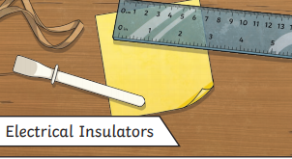  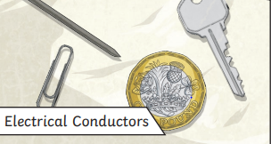  - Objects that are made from materials that do not allow electricity to pass through and do not complete a circuit are called electrical insulators.

Lyng Primary School Knowledge Organiser

Topic: | Science  Electricity and circuits | Year 4 | Summer
1. Name these components in circuit.
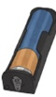  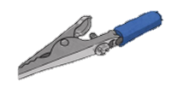  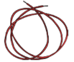  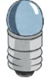  __________ __________ __________ __________ | S
__________ __________ __________ __________ | E

4. Will the bulb in these circuits be lit or not lit?
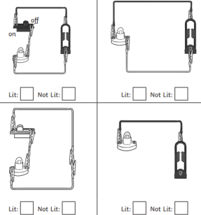  S | E

2. Name three things are electrical appliances which are powered by: | S | E
Mains operated | _______________  _______________  _______________ | ______________  ______________  ______________
Battery operated | _______________  _______________  _______________ | ______________  ______________  ______________
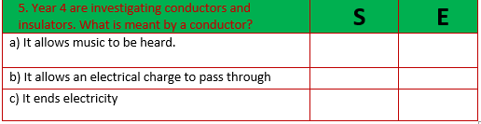
3. Which combination would make a simple complete circuit? | S | E
a) a buzzer, a battery and a bulb
b) a battery, a wire and a bulb
c) a bulb, a switch and a wire

